SS UPDATE DELETE QUERY

**UPDATE**

1. UPDATE obat SET nama_obat = 'Paramex' WHERE barcode = '909-181';

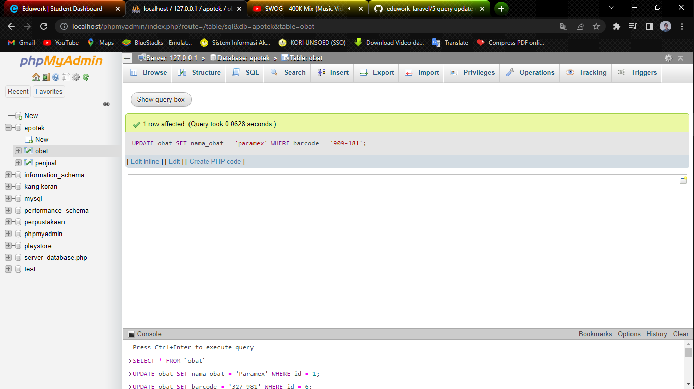

1. UPDATE obat SET barcode = ‘327-981’ WHERE id = 6

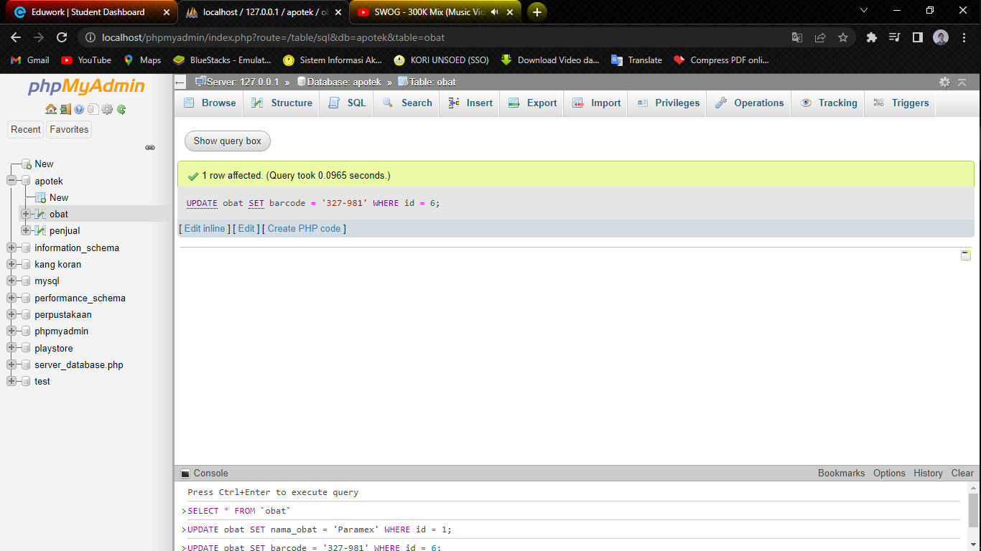

1. UPDATE obat SET id_harga = 3300 WHERE id = 4

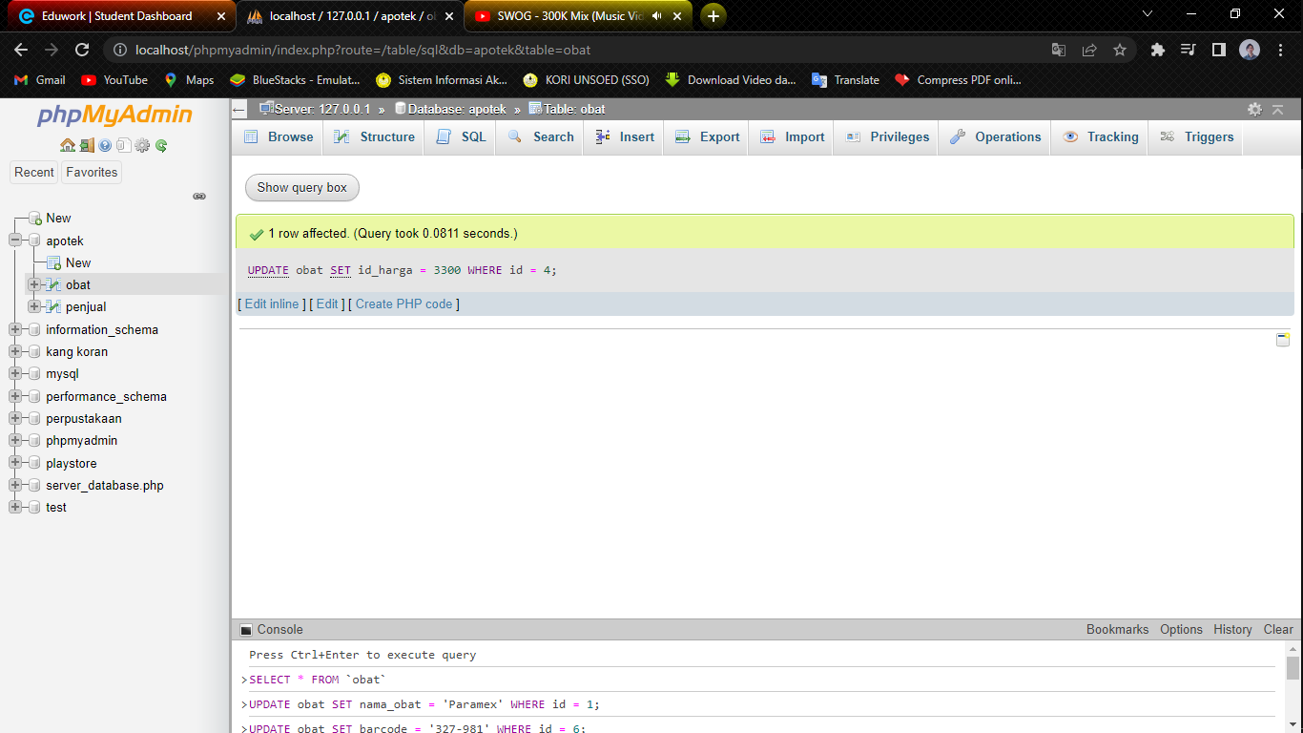

1. UPDATE obat SET qty_stock = 100 WHERE id = 5

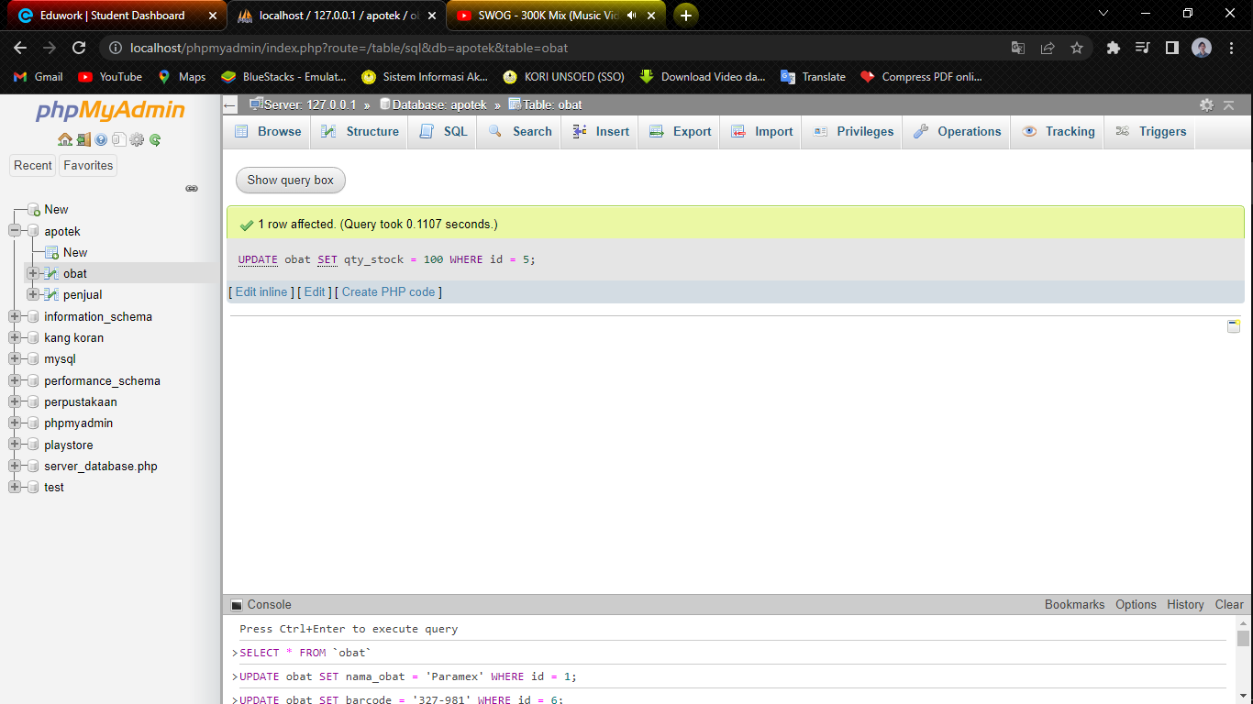

1. UPDATE obat SET tahun = 2022 WHERE id = 1;

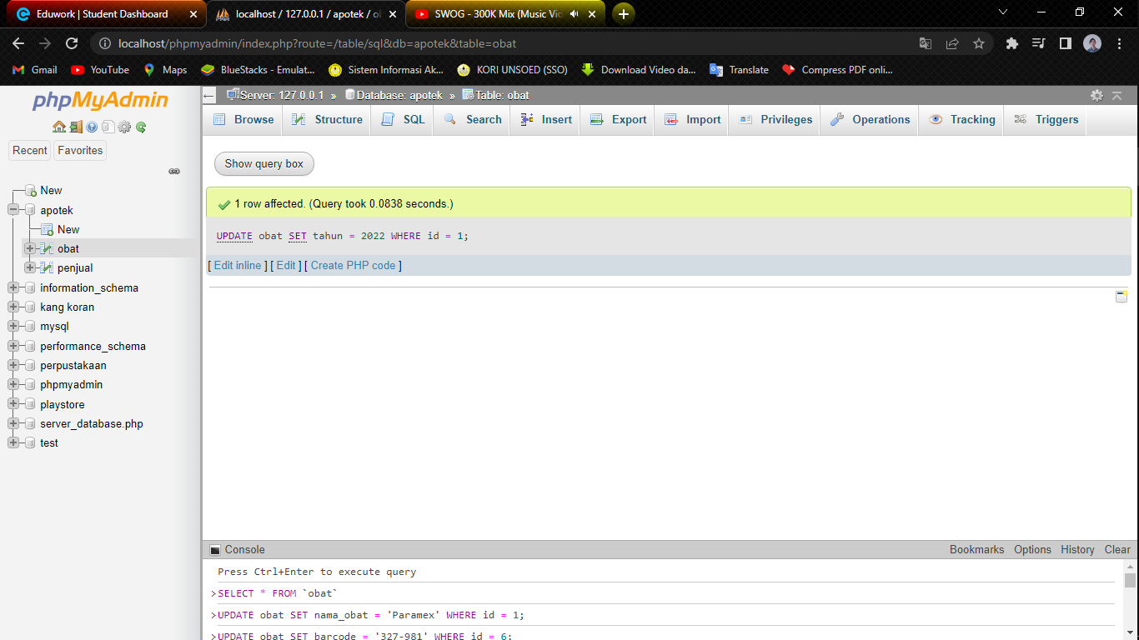

**DELETE**

1. DELETE FROM obat WHERE id = 1

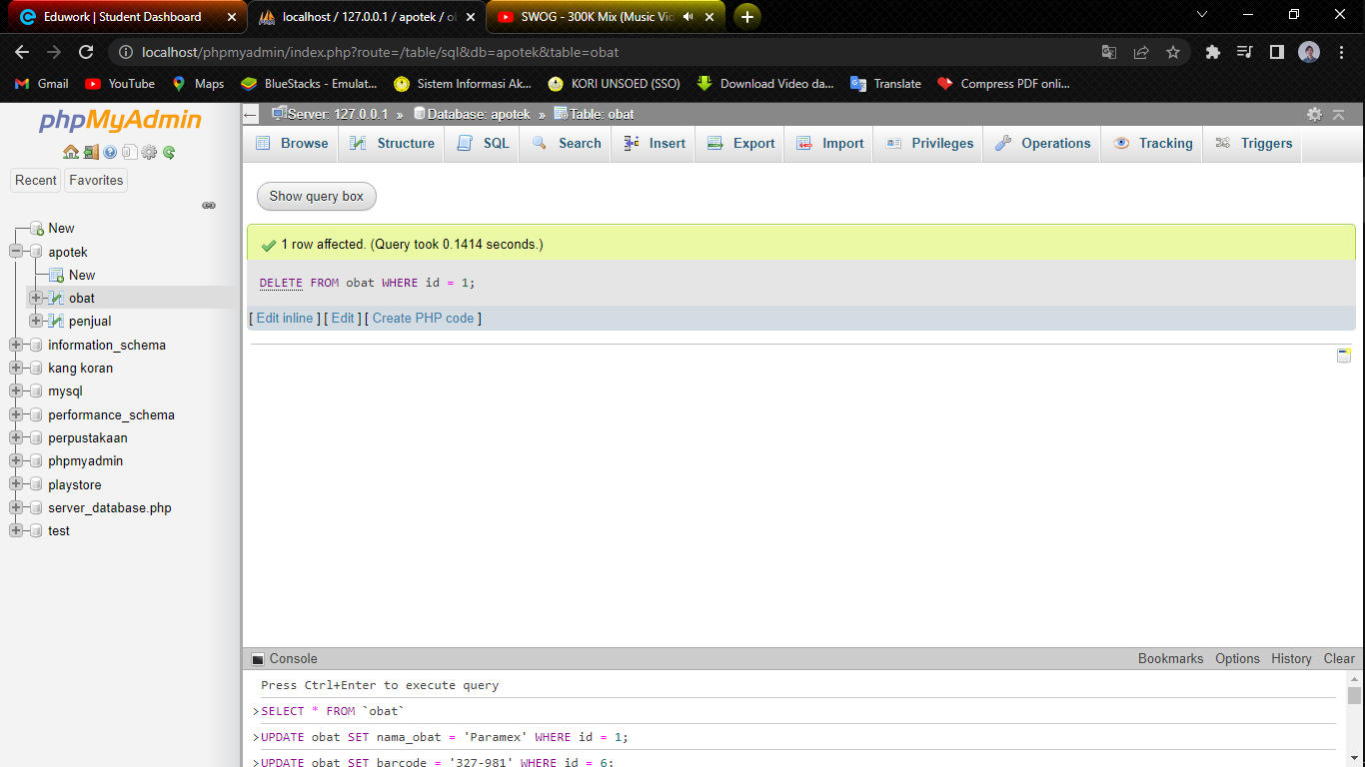

1. DELETE FROM obat WHERE id = 2

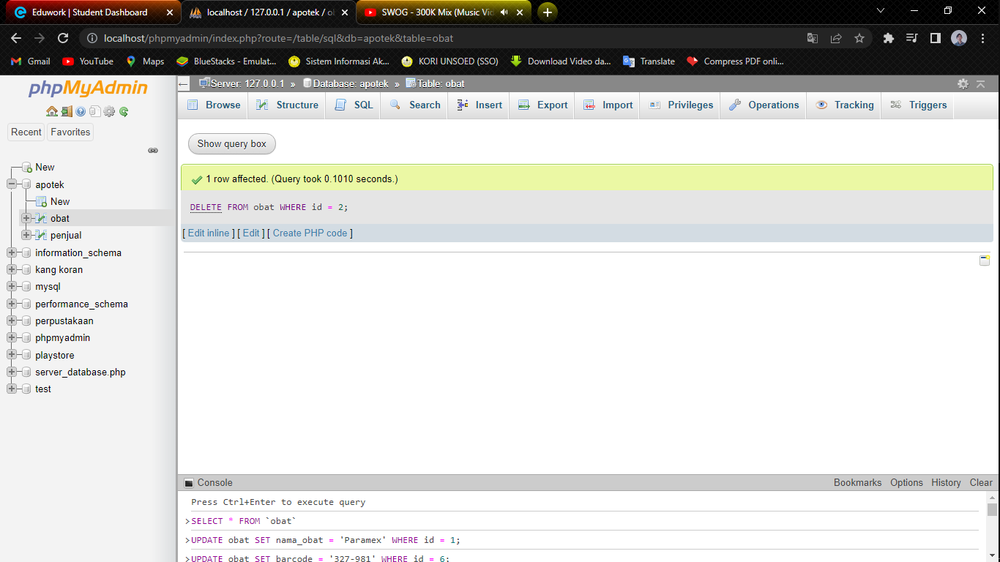

1. DELETE FROM obat WHERE id = 3

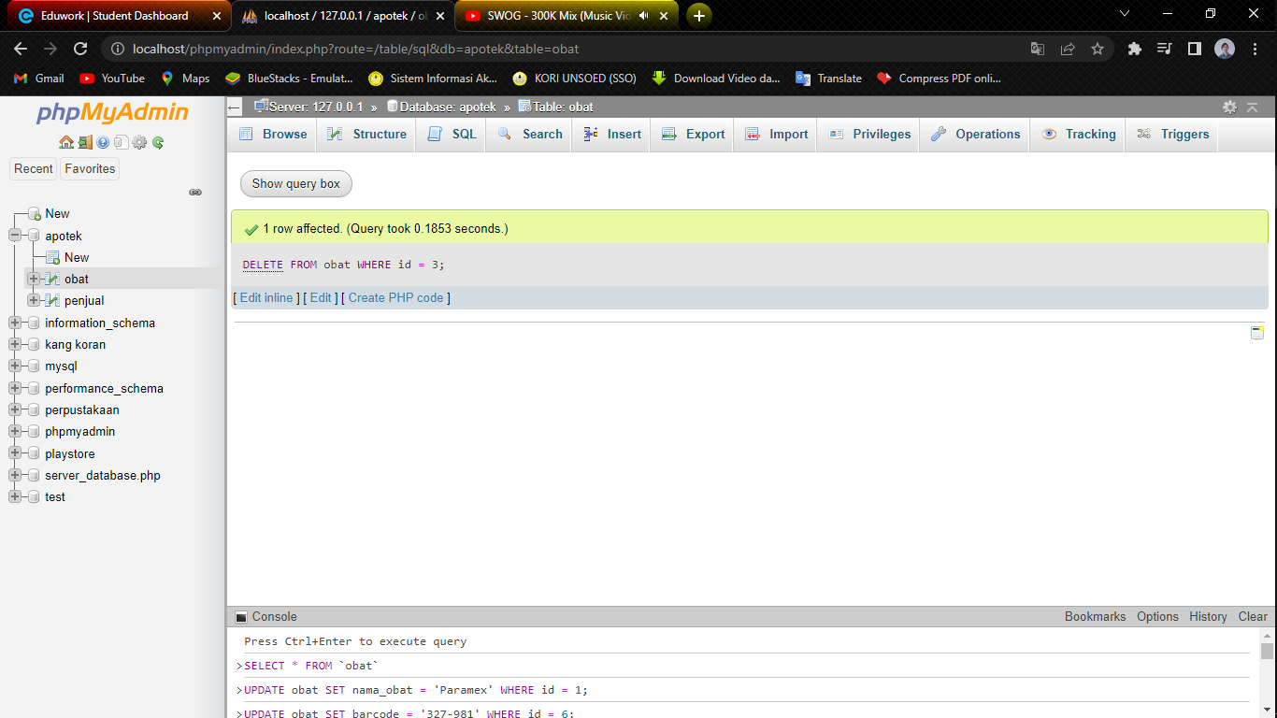

1. DELETE FROM obat WHERE id = 4

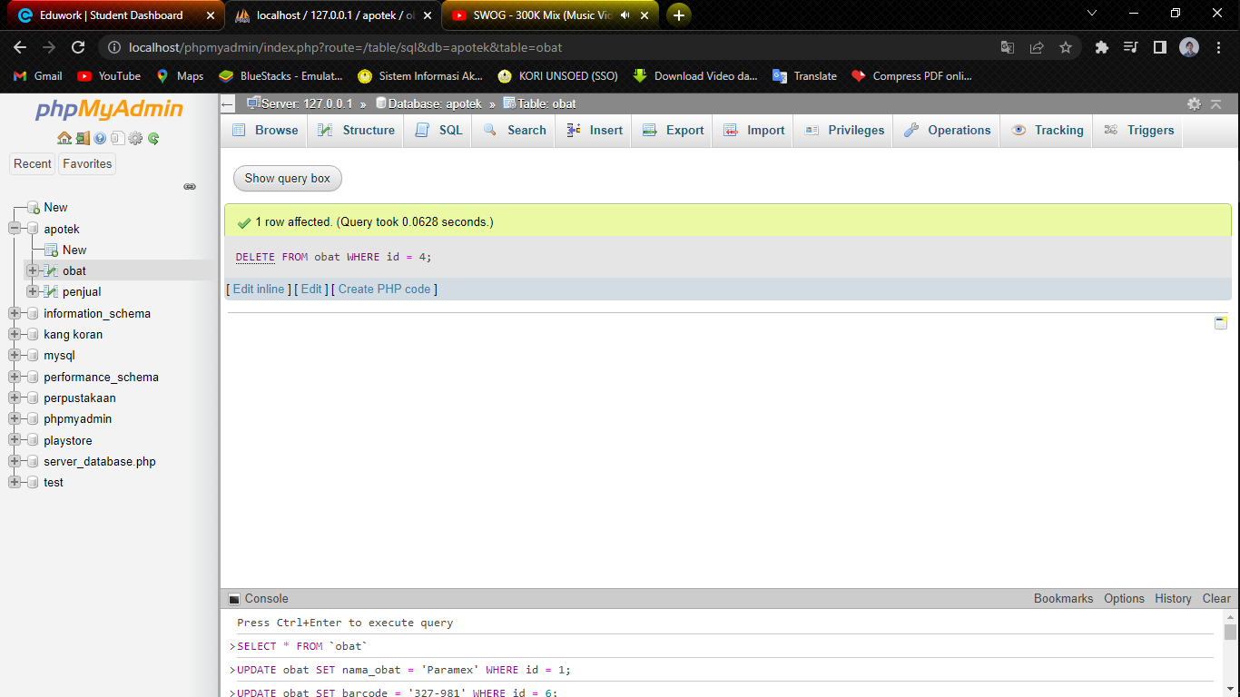

1. DELETE FROM obat WHERE id = 5

